**CS565: Cloud Computing**

**Reading Assignment 2**

|  |  |  |
| --- | --- | --- |
| **Solutions** | **Roll No.**: 1801CS31 | **Date**: 22-Apr-2022 |

**-------------------------------------------------------------------------------------------------------------**

**Ans 1**:

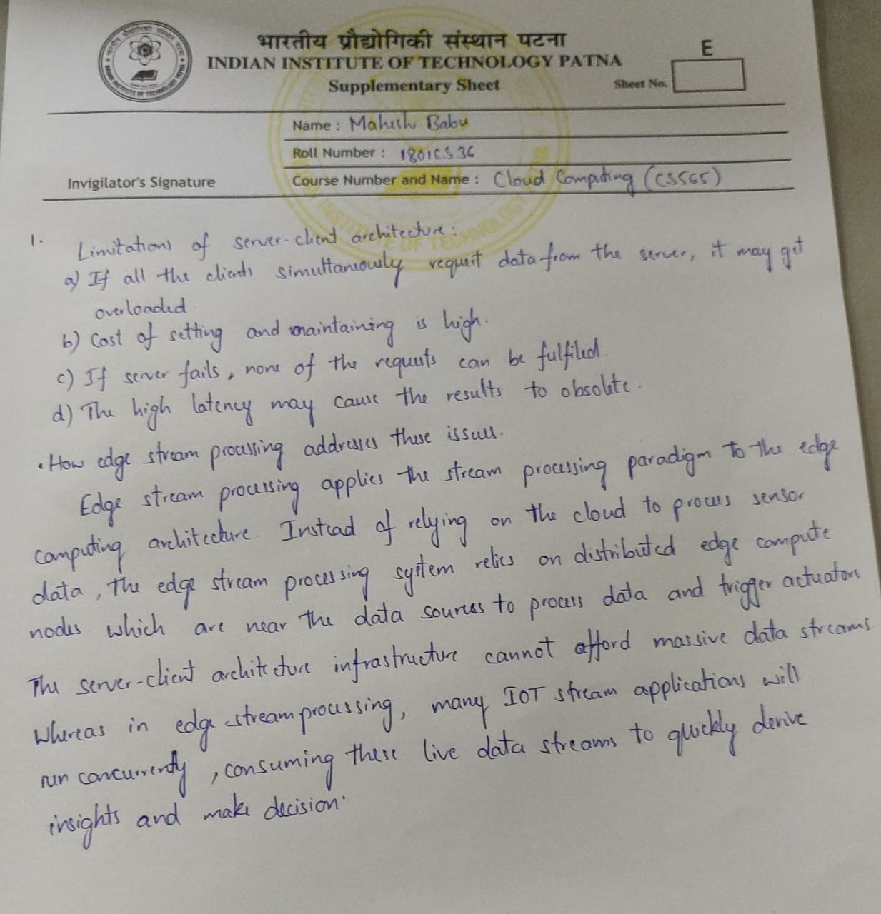

**Ans 2**:

<Answer goes here>

**Ans 3**:

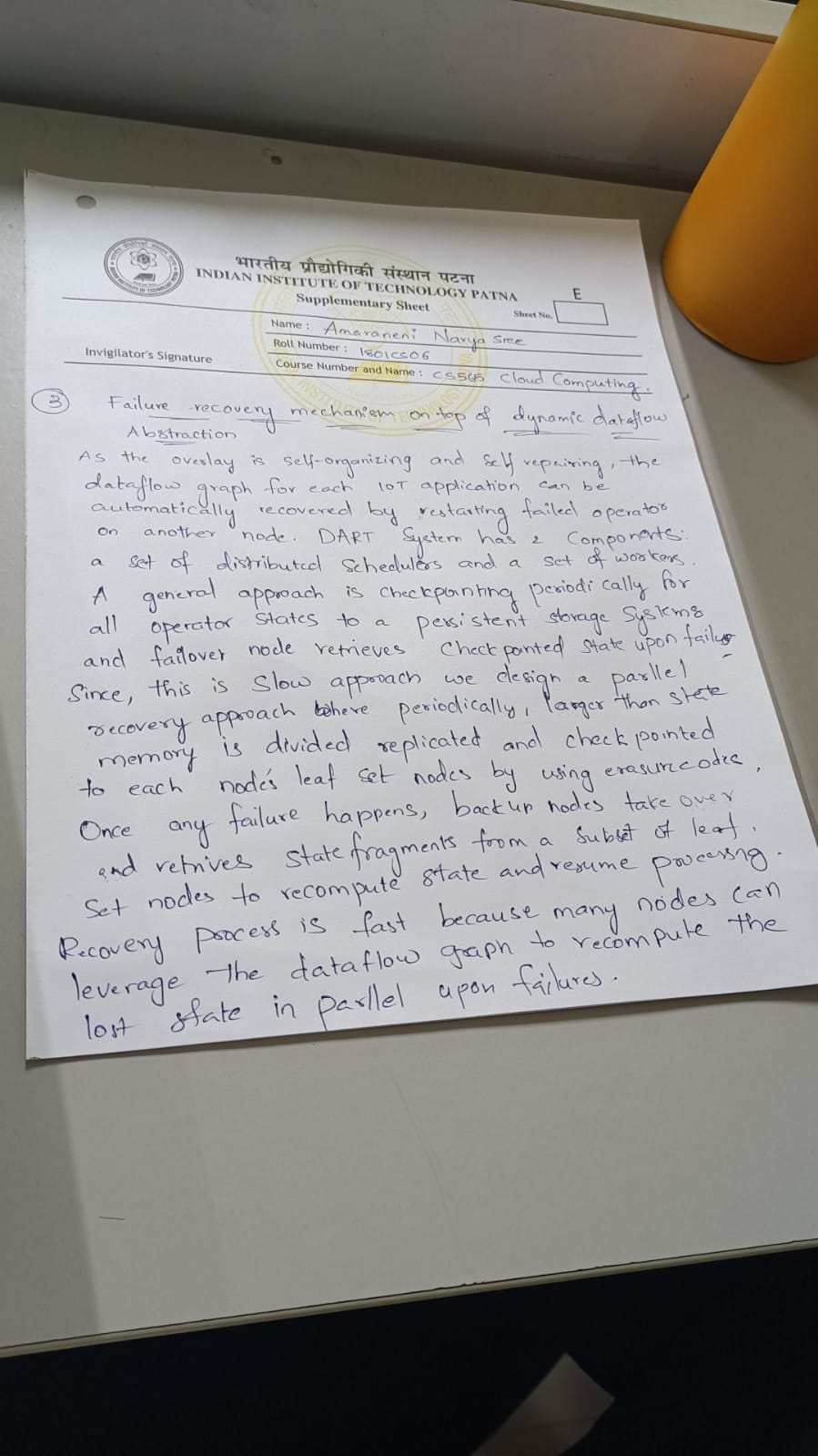

**Ans 4**:

